## Reports/Inventory Reports/ Drug Movement/Top/Bottom Drug

Request:

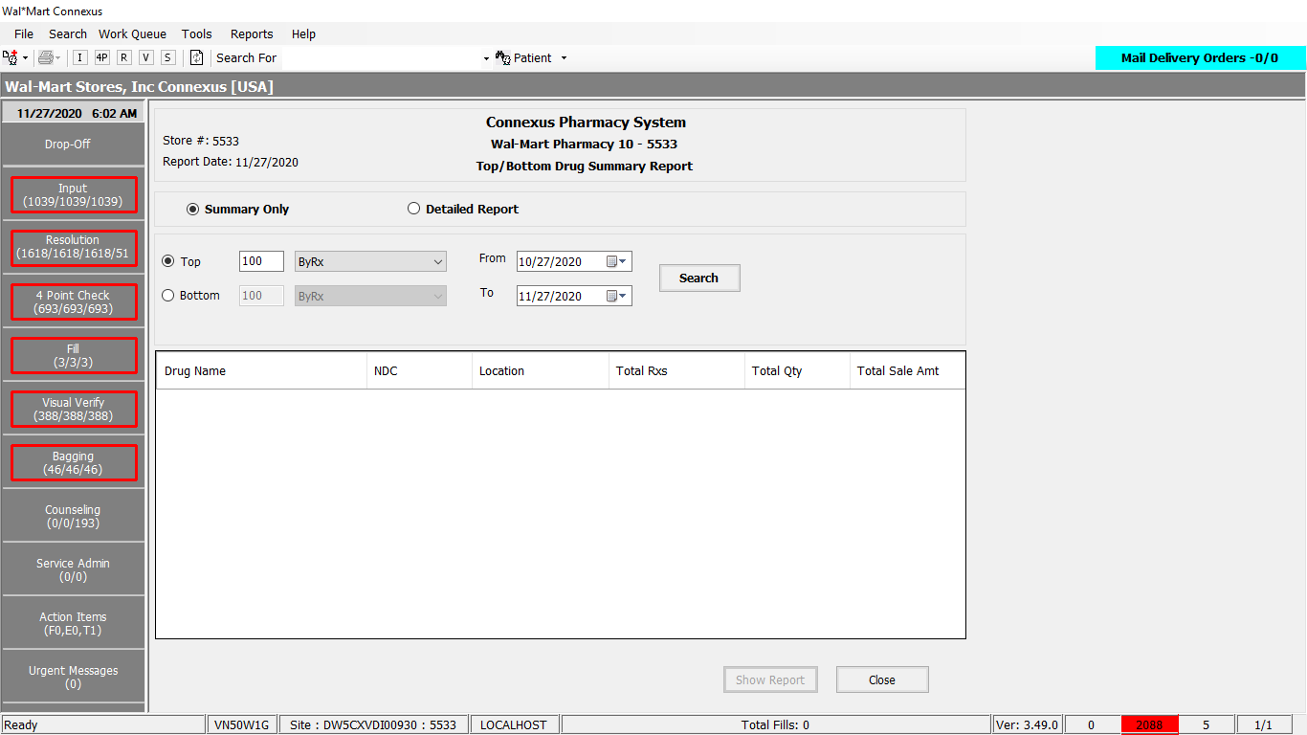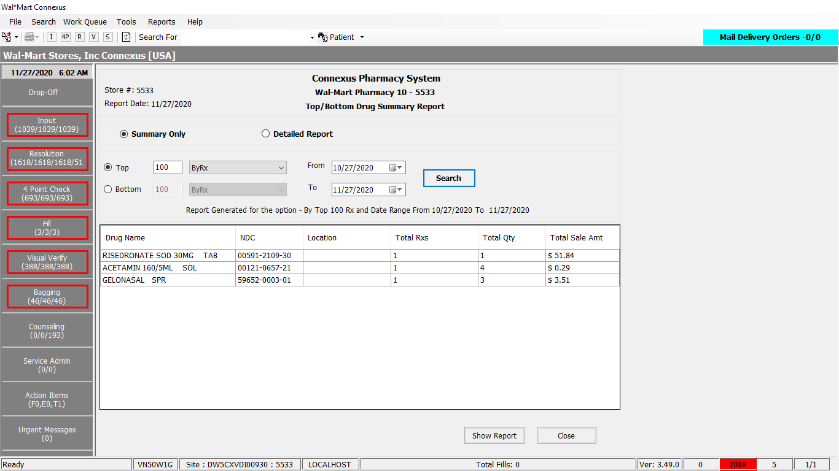

Response:

Summary report:

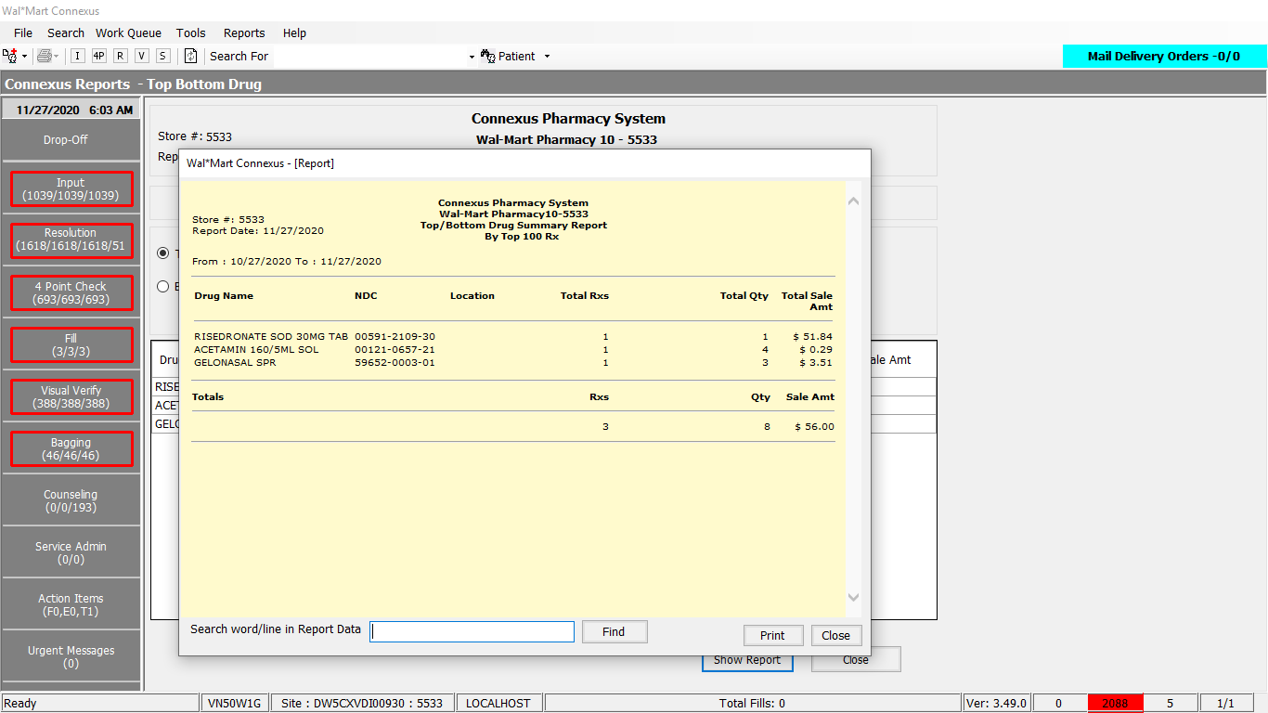

Detailed report:

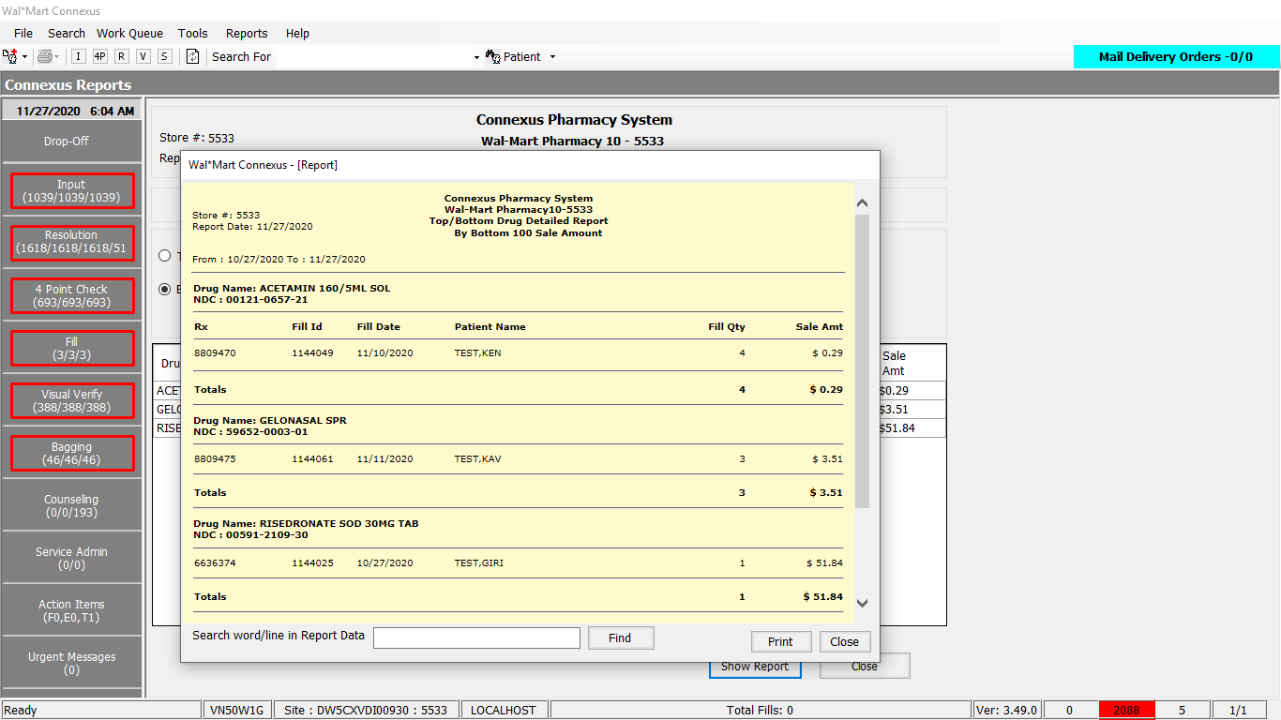

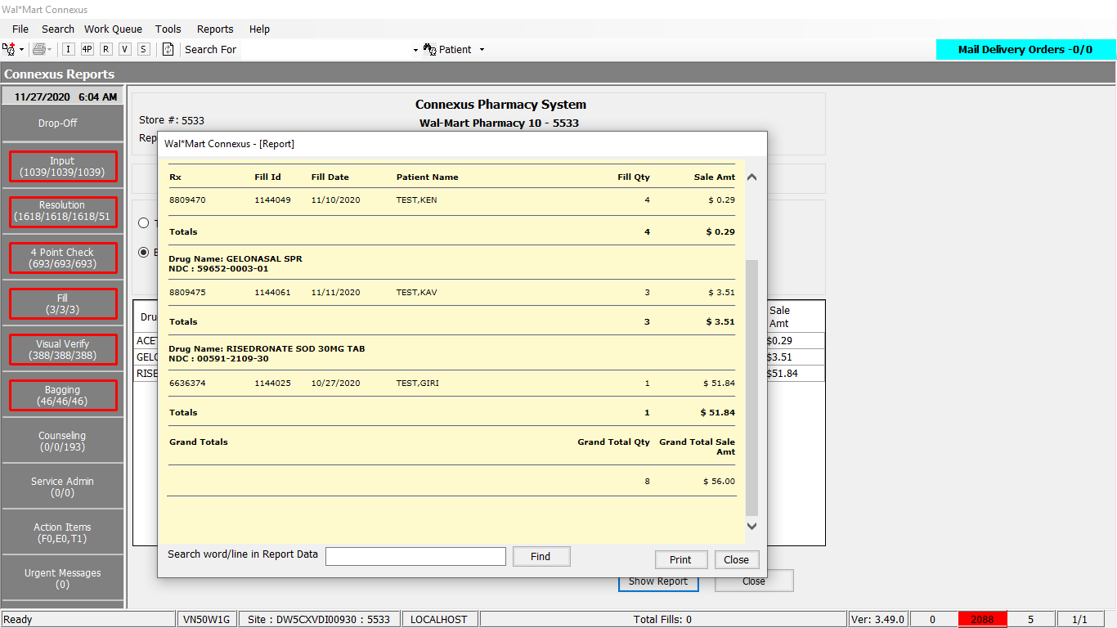

Queries:

1. Friend Const GetTopBottomDrugReportData1 As String = " SELECT FIRST ? UPPER(pp.short_name) short_name, CASE WHEN rx.compound_ind ='Y' THEN 'COMPOUND' ELSE pi.ndc_nbr END ndc_nbr, " &

" nvl(pir.issued_id_nbr,'') location, SUM(rf.fill_qty) total_qty, SUM(rf.pos_sale_amt) total_sale_amt, " &

" COUNT(rsd.rx_fill_id) totalrx FROM rx rx,rx_fill rf, rx_fill_item rfi,rx_sale_detail rsd, " &

" pharmacy_offering:pharmacy_product pp,pharmacy_offering:pharmacy_item pi, OUTER pharmacy_offering:phm_item_ref pir " &

" WHERE rx.rx_id = rf.rx_id AND rsd.rx_fill_id = rf.rx_fill_id AND rf.rx_fill_id=rfi.rx_fill_id AND " &

" pi.product_mds_fam_id=pp.product_mds_fam_id AND rfi.item_mds_fam_id=pi.mds_fam_id AND rf.pos_ts IS NOT NULL " &

" AND rf.pos_sale_amt IS NOT NULL AND rfi.item_seq_nbr = 1 AND rf.status_code = 20401 AND rf.fill_date >= ? AND " &

" rf.fill_date <= ? AND pir.mds_fam_id = pi.mds_fam_id AND pir.phm_item_ref_code = 3105 GROUP BY 1,2,3 ORDER BY "

2. Friend Const GetTopBottomDrugReportData2 As String = " SELECT rx.rx_id, rx.rx_nbr, UPPER(pp.short_name) short_name, CASE WHEN rx.compound_ind ='Y' THEN 'COMPOUND' ELSE pi.ndc_nbr END ndc_nbr, " &

" rf.rx_fill_id, rf.fill_date, " &

" TRIM(NVL(pat.last_name,'')) || ',' || TRIM(NVL(pat.first_name,'')) || ' ' || TRIM(NVL(pat.middle_name,'')) pat_name, " &

" rf.fill_qty, rf.pos_sale_amt " &

" FROM rx rx,rx_fill rf, patient pat, rx_fill_item rfi,rx_sale_detail rsd, pharmacy_offering:pharmacy_product pp, " &

" pharmacy_offering:pharmacy_item pi WHERE rx.rx_id = rf.rx_id AND rsd.rx_fill_id = rf.rx_fill_id AND rf.rx_fill_id=rfi.rx_fill_id AND " &

" pi.product_mds_fam_id=pp.product_mds_fam_id AND rfi.item_mds_fam_id=pi.mds_fam_id AND rx.patient_id = pat.patient_id AND rf.pos_ts IS NOT NULL " &

" AND rf.pos_sale_amt IS NOT NULL AND rfi.item_seq_nbr = 1 AND rf.status_code = 20401 AND rf.fill_date >= ? AND rf.fill_date <= ? AND ndc_nbr in({0})"

-----------------------------------------------------------------------------------------

3. Friend Const GetTopBottomDrugSummarySortReport As String = "SELECT short_name, ndc_nbr, total_qty, total_sale_amt, totalrx, location FROM ( {0} ) ORDER BY short_name ASC"

4. Friend Const GetTopBottomDrugDetailSortReport As String = "SELECT short_name, ndc_nbr, rx_id, rx_nbr, pat_name, rx_fill_id, fill_date, fill_qty, pos_sale_amt FROM ( {0} ) ORDER BY short_name ASC"

DAL:

Public Function GetTopBottomDrugReportData(ByVal siteId As Integer,

ByVal getTopBottomDrugReportDataInputInfo As _

GetTopBottomDrugReportDataInputInfoBE) As _

List(Of GetTopBottomDrugReportDataInfoBE) Implements IReportDAL.GetTopBottomDrugReportData

Using (New Tracer(ConnexusCommonConstants.ConnexusTracer))

Dim orderBy As String = Nothing

Dim ndc As String = Nothing

Dim bottom As String = Nothing

Dim sqlString As New StringBuilder

Dim sqlSortString As New StringBuilder

Dim paramList As New List(Of DbParameter)

Dim getTopBottomDrugReportBEList As New List(Of GetTopBottomDrugReportDataInfoBE)

If getTopBottomDrugReportDataInputInfo.TopBottom = 0 Then bottom = "DESC"

If getTopBottomDrugReportDataInputInfo.OrderBy = 0 Then

orderBy = "totalrx"

ElseIf getTopBottomDrugReportDataInputInfo.OrderBy = 1 Then

orderBy = "total_qty"

ElseIf getTopBottomDrugReportDataInputInfo.OrderBy = 2 Then

orderBy = "total_sale_amt"

End If

If getTopBottomDrugReportDataInputInfo.SummaryDetailed = 1 Then ndc = getTopBottomDrugReportDataInputInfo.Ndc

If getTopBottomDrugReportDataInputInfo.SummaryDetailed = 0 Then

'SQL Query for Summary Report

sqlString.Append(ReportQueries.GetTopBottomDrugReportData1)

sqlString.Append(orderBy & " " & bottom)

paramList.Add(ParameterHelper.BuildParameter("Rows", DbType.Int32, getTopBottomDrugReportDataInputInfo.TopBottomRows))

paramList.Add(ParameterHelper.BuildParameter("FillDate", DbType.Date, getTopBottomDrugReportDataInputInfo.FromDate))

paramList.Add(ParameterHelper.BuildParameter("FillToDatE", DbType.Date, getTopBottomDrugReportDataInputInfo.ToDate))

Else

'SQL Query for Detailed

'Inventory Changes - Start

'Modified the query to pass the NDC list

sqlString.AppendFormat(ReportQueries.GetTopBottomDrugReportData2, ndc)

paramList.Add(ParameterHelper.BuildParameter("FillDate", DbType.Date, getTopBottomDrugReportDataInputInfo.FromDate))

paramList.Add(ParameterHelper.BuildParameter("FillToDatE", DbType.Date, getTopBottomDrugReportDataInputInfo.ToDate))

End If

Dim dataReader As IDataReader

'Added new option to sort the report by Drug Name.

'If the property OrderByDrugName is TRUE sort the result by Drug Name.

If getTopBottomDrugReportDataInputInfo.OrderByDrugName Then

If getTopBottomDrugReportDataInputInfo.SummaryDetailed = 0 Then

sqlSortString.AppendFormat(ReportQueries.GetTopBottomDrugSummarySortReport, sqlString.ToString)

Else

sqlSortString.AppendFormat(ReportQueries.GetTopBottomDrugDetailSortReport, sqlString.ToString)

End If

dataReader = ExecuteReader(DatabaseEnum.rx21c, siteId, sqlSortString.ToString, paramList)

Else

dataReader = ExecuteReader(DatabaseEnum.rx21c, siteId, sqlString.ToString, paramList)

End If

'Inventory Changes - End

Dim getTopBottomDrugReportBE As GetTopBottomDrugReportDataInfoBE

While dataReader.Read

getTopBottomDrugReportBE = New GetTopBottomDrugReportDataInfoBE

If Not getTopBottomDrugReportDataInputInfo.SummaryDetailed = 0 Then

If Not dataReader.IsDBNull(dataReader.GetOrdinal("fill_date")) Then

getTopBottomDrugReportBE.FillDate = CDate(dataReader("fill_date"))

End If

If Not dataReader.IsDBNull(dataReader.GetOrdinal("pat_name")) Then

getTopBottomDrugReportBE.PatName = CStr(dataReader("pat_name")).Trim

End If

If Not dataReader.IsDBNull(dataReader.GetOrdinal("pos_sale_amt")) Then

getTopBottomDrugReportBE.PosSaleAmt = CDec(dataReader("pos_sale_amt"))

End If

If Not dataReader.IsDBNull(dataReader.GetOrdinal("rx_fill_id")) Then

getTopBottomDrugReportBE.RxFillId = CInt(dataReader("rx_fill_id"))

End If

If Not dataReader.IsDBNull(dataReader.GetOrdinal("rx_id")) Then

getTopBottomDrugReportBE.RxId = CInt(dataReader("rx_id"))

End If

If Not dataReader.IsDBNull(dataReader.GetOrdinal("rx_nbr")) Then

getTopBottomDrugReportBE.RxNbr = CInt(dataReader("rx_nbr"))

End If

If Not dataReader.IsDBNull(dataReader.GetOrdinal("fill_qty")) Then

getTopBottomDrugReportBE.FillQty = CInt(dataReader("fill_qty"))

End If

Else

If Not dataReader.IsDBNull(dataReader.GetOrdinal("total_qty")) Then

getTopBottomDrugReportBE.TotalQty = CInt(dataReader("total_qty"))

End If

If Not dataReader.IsDBNull(dataReader.GetOrdinal("totalrx")) Then

getTopBottomDrugReportBE.TotalRx = CInt(dataReader("totalrx"))

End If

If Not dataReader.IsDBNull(dataReader.GetOrdinal("total_sale_amt")) Then

getTopBottomDrugReportBE.TotalSaleAmt = CDec(dataReader("total_sale_amt"))

End If

'Inventory Management - Changes

'Added new column location to the result set.

If Not dataReader.IsDBNull(dataReader.GetOrdinal("location")) Then

getTopBottomDrugReportBE.Location = CStr(dataReader("location"))

End If

End If

If Not dataReader.IsDBNull(dataReader.GetOrdinal("ndc_nbr")) Then

getTopBottomDrugReportBE.NdcNbr = CStr(dataReader("ndc_nbr")).Trim

End If

If Not dataReader.IsDBNull(dataReader.GetOrdinal("short_name")) Then

getTopBottomDrugReportBE.ShortName = CStr(dataReader("short_name")).Trim

End If

getTopBottomDrugReportBEList.Add(getTopBottomDrugReportBE)

End While

If getTopBottomDrugReportBEList.Count > 0 Then

Return getTopBottomDrugReportBEList

Else

Return Nothing

End If

End Using

End Function